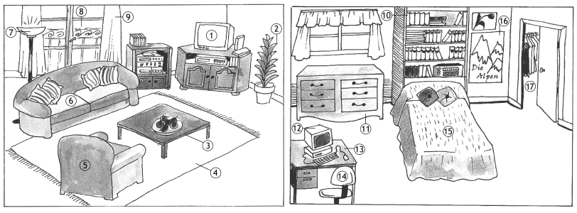**Das Möbel.** *Unten sehen Sie zwei Zimmer. Geben Sie die deutschen Wörter für die Möbel und Objekte in den Zimmern an.*

|  |
| --- |
|  |

|  |  |  |  |
| --- | --- | --- | --- |
| 1 | ___________________________________ | 10. | ________________________________________ |
| 2. | ________________________________________ | 11. | ________________________________________ |
| 3. | ________________________________________ | 12. | ________________________________________ |
| 4. | ________________________________________ | 13. | ________________________________________ |
| 5. | ________________________________________ | 14. | ________________________________________ |
| 6. | ________________________________________ | 15. | ________________________________________ |
| 7. | ________________________________________ | 16. | ________________________________________ |
| 8. | ________________________________________ | 17. | ________________________________________ |